**ER Diagram:**

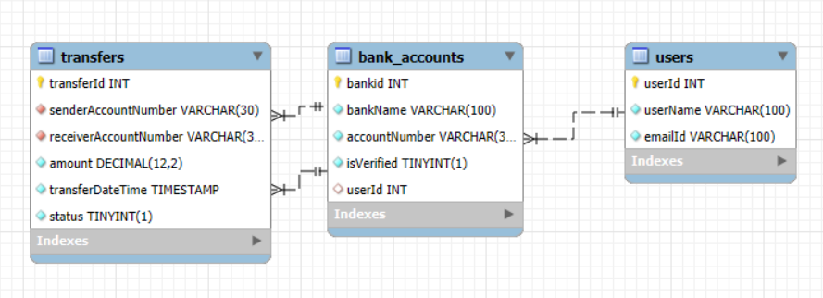

**CODE:**

-- "users" table which represents all users

CREATE TABLE users (

userId INT PRIMARY KEY,

userName VARCHAR(100) NOT NULL,

emailId VARCHAR(100) NOT NULL

);

-- "bank_accounts" which represents all the bank accounts

CREATE TABLE bank_accounts (

bankid INT PRIMARY KEY,

bankName VARCHAR(100) NOT NULL,

accountNumber VARCHAR(30) UNIQUE NOT NULL,

isVerified BOOLEAN NOT NULL,

userId INT,

FOREIGN KEY (userId) REFERENCES users(userId)

);

-- "transfers" table which represents all the transfers made

CREATE TABLE transfers (

transferId INT PRIMARY KEY,

senderAccountNumber VARCHAR(30) NOT NULL,

receiverAccountNumber VARCHAR(30) NOT NULL,

amount DECIMAL(12,2) NOT NULL,

transferDateTime TIMESTAMP NOT NULL,

status BOOLEAN NOT NULL,

FOREIGN KEY (senderAccountNumber) REFERENCES bank_accounts(accountNumber),

FOREIGN KEY (receiverAccountNumber) REFERENCES bank_accounts(accountNumber)

);

-- Inserting values to "users" table

INSERT INTO users (userId, userName, emailId) VALUES

(1, 'Rahul Verma', 'rahul.verma@example.com'),

(2, 'Sneha Kapoor', 'sneha.kapoor@example.com'),

(3, 'Vikram Singh', 'vikram.singh@example.com'),

(4, 'Meera Nair', 'meera.nair@example.com');

-- Inserting values to "bank_accounts" table

INSERT INTO bank_accounts (bankId, bankName, accountNumber, isVerified, userId) VALUES

(101, 'HDFC', 'ACC123456', TRUE, 1),

(102, 'ICICI', 'ACC234567', TRUE, 1),

(103, 'SBI', 'ACC345678', FALSE, 2),

(104, 'Axis', 'ACC456789', TRUE, 3),

(105, 'Kotak', 'ACC567890', TRUE, 4);

-- Inserting values to "transfers" table

INSERT INTO transfers (transferId, senderAccountNumber, receiverAccountNumber, amount, transferDateTime, status) VALUES

(1001, 'ACC123456', 'ACC234567', 5000.00, '2025-07-30 10:00:00', TRUE),

(1002, 'ACC234567', 'ACC345678', 1500.50, '2025-07-30 11:15:00', TRUE),

(1003, 'ACC345678', 'ACC456789', 2500.75, '2025-07-31 09:30:00', FALSE),

(1004, 'ACC456789', 'ACC567890', 3200.00, '2025-07-31 12:45:00', TRUE);

-- Describing "users" table

DESC users;

-- Displaying "users" table data

SELECT * FROM users;

-- Describing "bank_accounts" table

DESC bank_accounts;

-- Displaying "bank_accounts" table data

SELECT * FROM bank_accounts;

-- Describing "transfers" table

DESC transfers;

-- Displaying "transfers" table data

SELECT * FROM transfers;

